Experiment NO:2

Aim:To get the function of command of linux command

1 pwd: check your current location



2.whoami: display name of current logged-in user



3.date: check system date or time

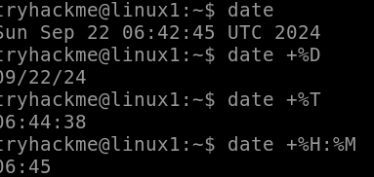

4.ls:display files and directory present in current location

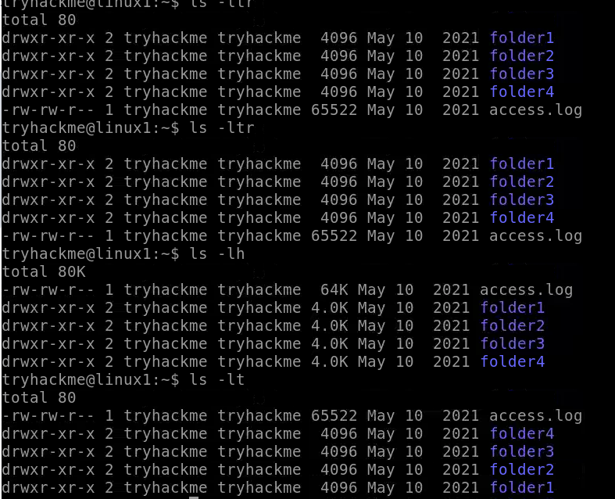

5.clear: clear the linux terminal



6 touch <file_name>: Create a file in linux

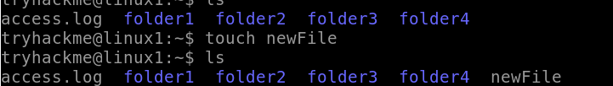

7 rm <file_name>:delete a file in Linux

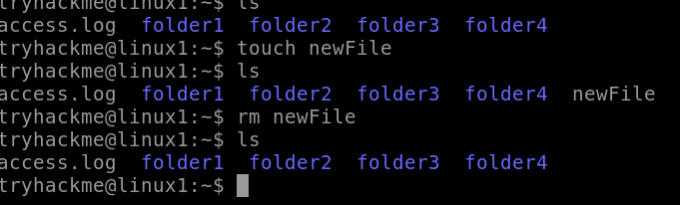

8 vi <file_name>: Create a file and edit a file in linux

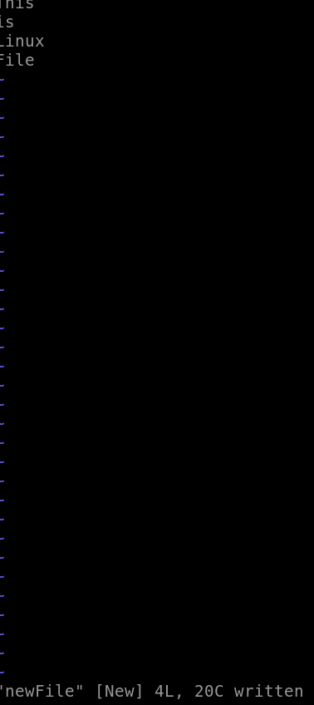

9 nano <file_name>: Edit a file in linux

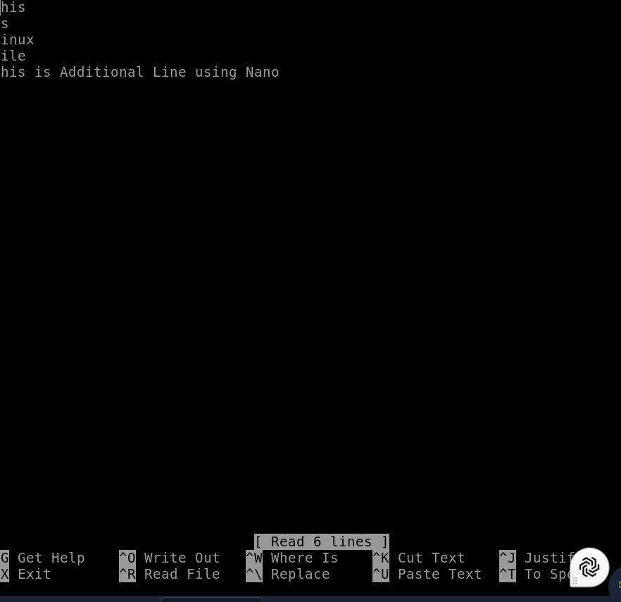

10 cat <file>: display content of a file on terminal

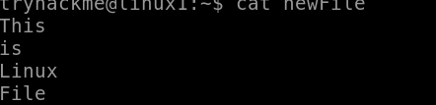

11 mkdir <dir_name>: create a directory/folder in Linux

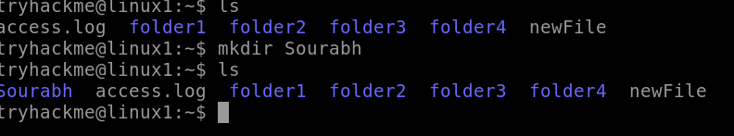

12 rmdir <dir_name> /rm-rf <dir_name> : Delete a directory /folder in Linux

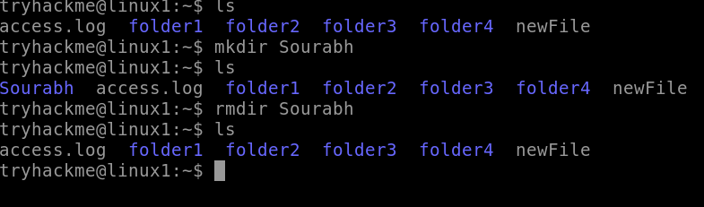

13 cd /path/folder cd.. : change path or move to another folder in Linux

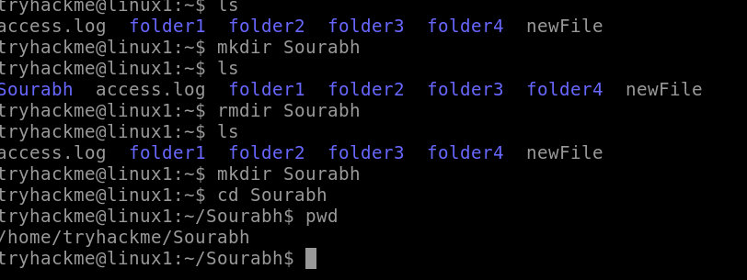

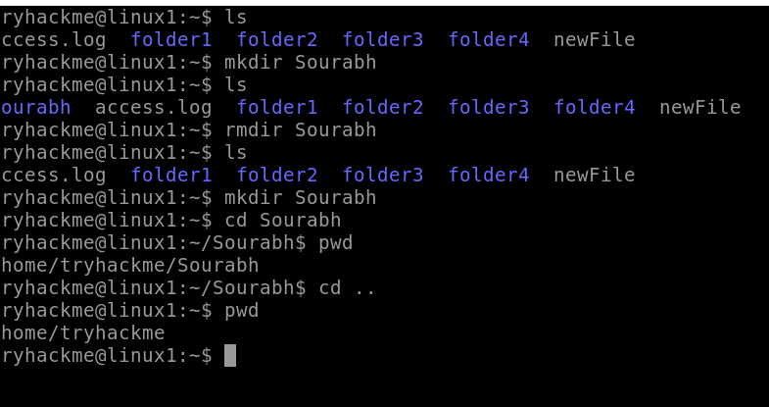

14 cp <file> /dest/path: copy and paste a file from one folder to another in Linux

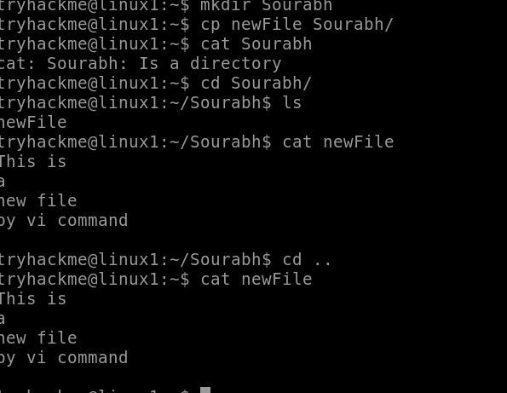

15 cat >newfile.txt: **Create a new file from terminal input**:

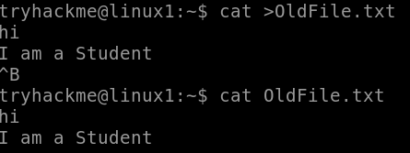

After typing this command, you can enter text directly, and it will be saved to newfile.txt when you press Ctrl+D to end the input.

16 mv: Rename Files or Directories

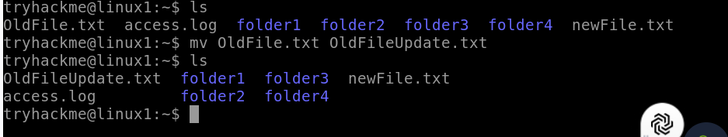

17 cal: **Display the current month**:

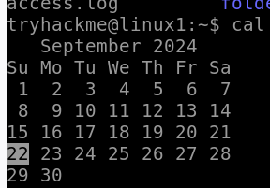

**Display a specific month and year**:

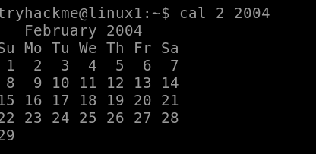

**Display a specific year**:

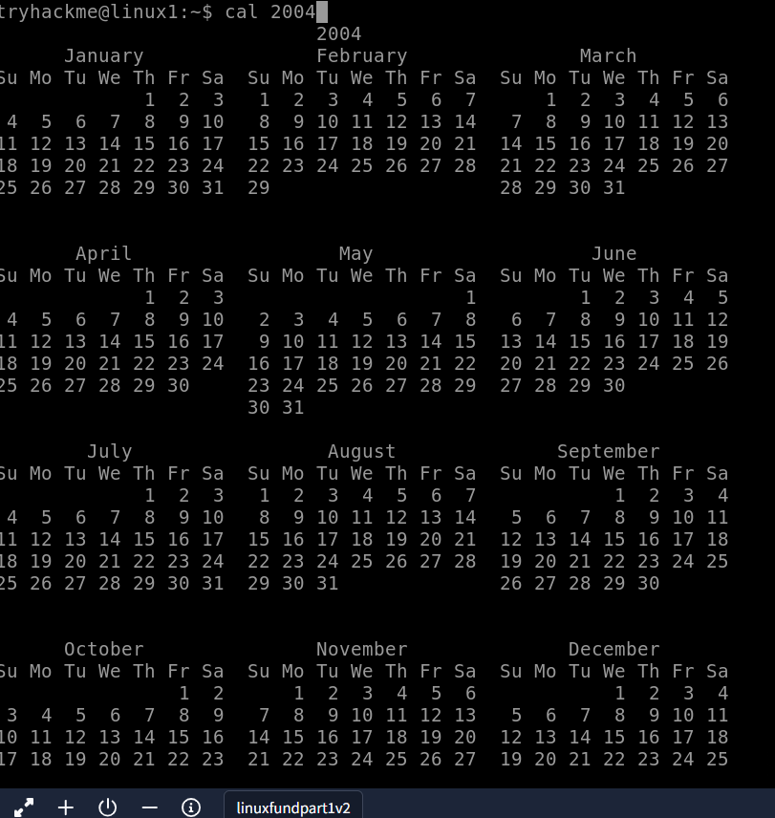

18 sort file/sort -r file:sort the content from a file in Linux

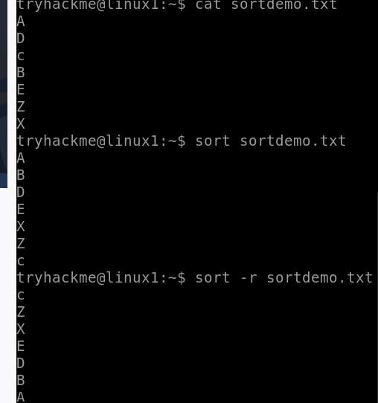

19 sort file | uniq: display UNIQUE content from a file in Linux

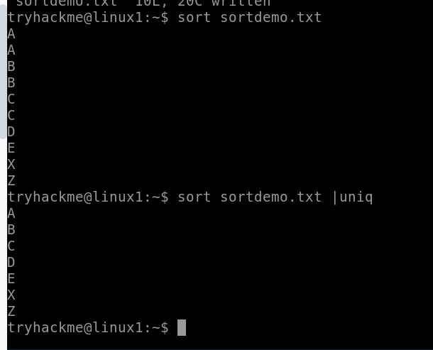

20 split -l 3 file:split this file in 3 different files in Linux

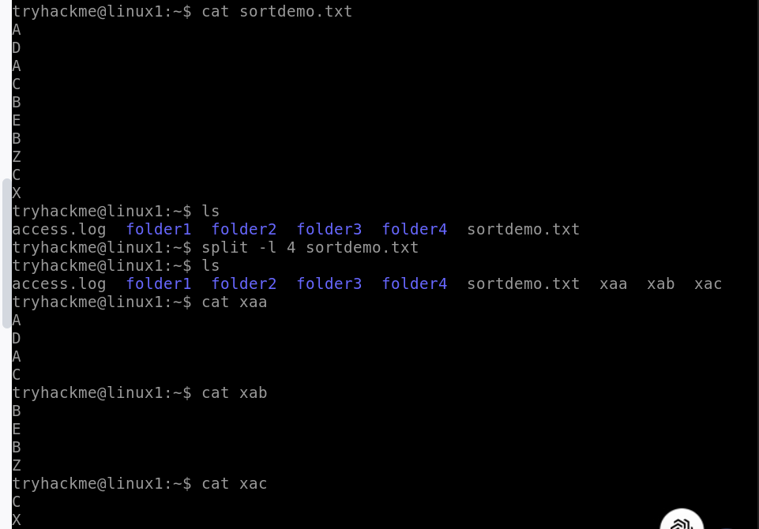

21 cmp filesA filesB: check if two files are identical or not in Linux

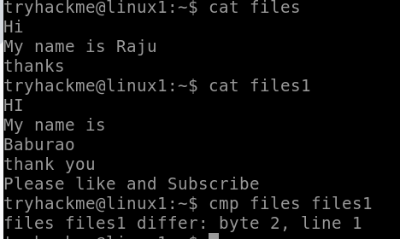

22 diff -u filesA filesB: compare and display difference between two files in Linux

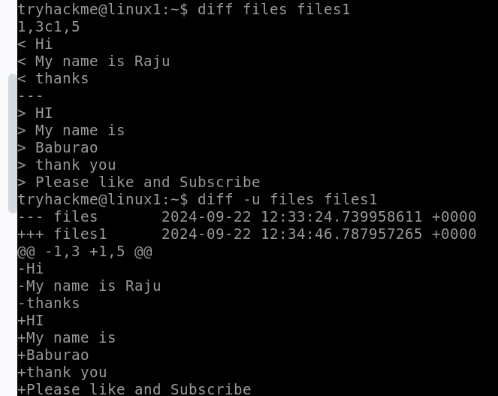

23 wc -l file: count no. of lines in a file in Linux

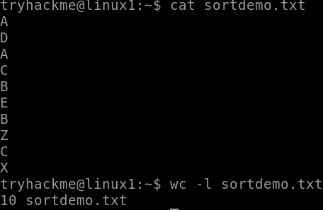

24 bc: to use calculator in Linux

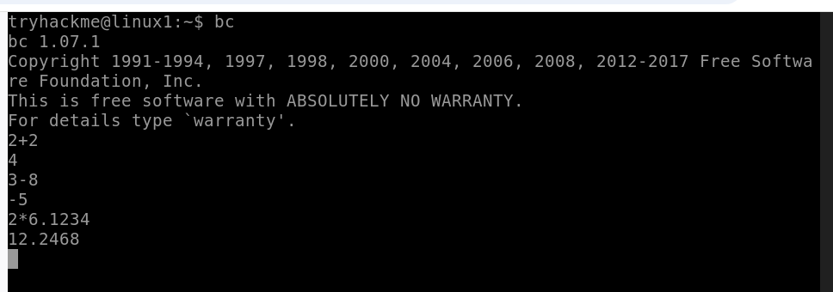

25 uptime: to check How long server has been running in Linux



26 echo: The echo command prints the specified text or variables to the terminal or into a file.

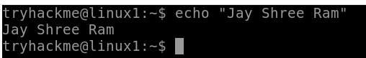

9 less <file>: read a file and Search for a word

10 more <file>: view content of a file page by page